**1.4 Arithmetic Operations**

**Description:** Using the operators +, -, *, / to perform simple arithmetics using numbers

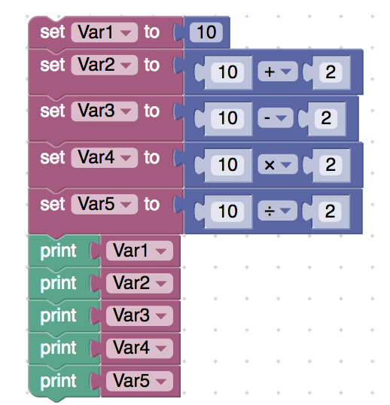

<xml xmlns="http://www.w3.org/1999/xhtml">

 <variables>

    <variable type="" id="*,lV:O9]V=@;iJO}p2/?">Var1</variable>

    <variable type="" id="1|(vdXAr5tg^;##J+BZ*">Var2</variable>

    <variable type="" id="`n2F%i@zey@j#D_$:Yx(">Var3</variable>

    <variable type="" id="idL9YP)lf^0({Ias/K?=">Var4</variable>

    <variable type="" id="zW}EI2x9L@ZyN#Y0/j}w">Var5</variable>

 </variables>

 <block type="variables_set" id="0=K:{+Y_rPspSV(f(z+l" x="-562" y="-238">

    <field name="VAR" id="*,lV:O9]V=@;iJO}p2/?" variabletype="">Var1</field>

    <value name="VALUE">

     <block type="math_number" id="8B!jrW)kAjx[NnqHrz!9">

       <field name="NUM">10</field>

     </block>

    </value>

    <next>

     <block type="variables_set" id="Ejypk`-Q3H7^dn)VzipT">

       <field name="VAR" id="1|(vdXAr5tg^;##J+BZ*" variabletype="">Var2</field>

       <value name="VALUE">

         <block type="math_arithmetic" id="N|,$my{FH;Tn:$VG-fXV">

           <field name="OP">ADD</field>

           <value name="A">

             <shadow type="math_number" id="I!j{,decl*~~bY+`d,`o">

               <field name="NUM">10</field>

             </shadow>

           </value>

           <value name="B">

             <shadow type="math_number" id="%Y#u}k36n:3$ikTn)?TS">

               <field name="NUM">2</field>

             </shadow>

           </value>

         </block>

       </value>

       <next>

         <block type="variables_set" id="bH7Sy_BqH~q.DnFe8S-~">

           <field name="VAR" id="`n2F%i@zey@j#D_$:Yx(" variabletype="">Var3</field>

           <value name="VALUE">

             <block type="math_arithmetic" id="I{4-j-L1.TcVcx}k]PY|">

               <field name="OP">MINUS</field>

               <value name="A">

<shadow type="math_number" id="a~%u8?%Fo*aRyoM}6b9%">

                   <field name="NUM">10</field>

                 </shadow>

               </value>

               <value name="B">

                 <shadow type="math_number" id="(CVy{e6z;+_m7cRDJ0KU">

                   <field name="NUM">2</field>

                 </shadow>

               </value>

             </block>

           </value>

           <next>

             <block type="variables_set" id="LZ_e)Ey{af%hapBM8-1O">

               <field name="VAR" id="idL9YP)lf^0({Ias/K?=" variabletype="">Var4</field>

               <value name="VALUE">

                 <block type="math_arithmetic" id="9I|:)aZY64f(nTzL~JfF">

                   <field name="OP">MULTIPLY</field>

                   <value name="A">

                     <shadow type="math_number" id="%|%J:Mdp/#SCg)3*_-tz">

                       <field name="NUM">10</field>

                     </shadow>

                   </value>

                   <value name="B">

                     <shadow type="math_number" id="]_mx)1k@AGcVH59HrVQE">

                       <field name="NUM">2</field>

                     </shadow>

    </value>

                 </block>

               </value>

               <next>

                 <block type="variables_set" id="p.3ESZBj#3Lk|,rv]Upk">

                   <field name="VAR" id="zW}EI2x9L@ZyN#Y0/j}w" variabletype="">Var5</field>

                   <value name="VALUE">

                     <block type="math_arithmetic" id="~BOF?K+b7,]QN_aM8I-6">

                       <field name="OP">DIVIDE</field>

                       <value name="A">

                         <shadow type="math_number" id="Wp3:-%9UCrK-F{}+z[m8">

                           <field name="NUM">10</field>

                         </shadow>

                       </value>

                       <value name="B">

                         <shadow type="math_number" id="Ll?gFwhtw.f2orRykFy!">

                           <field name="NUM">2</field>

                         </shadow>

                       </value>

                     </block>

                   </value>

                   <next>

                     <block type="text_print" id="Rp9!.J@Z*Qcr!RFXhd*^">

                       <value name="TEXT">

                         <shadow type="text" id="kGBiGZ=^!gjy.U_J+40o">

                           <field name="TEXT">abc</field>

                         </shadow>

                         <block type="variables_get" id="pn*Y,bzVy.ht!~U7A*ox">

                           <field name="VAR" id="*,lV:O9]V=@;iJO}p2/?" variabletype="">Var1</field>

                         </block>

                       </value>

                       <next>

<block type="text_print" id="H0$olSbzSgKUEcfcT($p">

                           <value name="TEXT">

                             <shadow type="text" id="0/?|fWVThpjbN=uATpYe">

                               <field name="TEXT">abc</field>

                             </shadow>

                             <block type="variables_get" id="jx*/p}}J*~b28==/4:Da">

                               <field name="VAR" id="1|(vdXAr5tg^;##J+BZ*" variabletype="">Var2</field>

                             </block>

                           </value>

                           <next>

                             <block type="text_print" id="jVT1]#aC@L5Rl,L=se%B">

                               <value name="TEXT">

                                 <shadow type="text" id="=EP.6Zgj!u$_:(ht#]Pb">

                                   <field name="TEXT">abc</field>

                                 </shadow>

                                 <block type="variables_get" id="}R#ML8]_H5Wjzz-nF6eP">

                                   <field name="VAR" id="`n2F%i@zey@j#D_$:Yx(" variabletype="">Var3</field>

                                 </block>

                               </value>

                               <next>

                                 <block type="text_print" id="Cv!_TxE[Pxm2F??INA8-">

                                   <value name="TEXT">

                                     <shadow type="text" id="vP)zJLxUDg;aWV6v8s17">

                                       <field name="TEXT">abc</field>

                                     </shadow>

    <block type="variables_get" id="gH.^#-;3mMr1IGNtf|sw">

                                       <field name="VAR" id="idL9YP)lf^0({Ias/K?=" variabletype="">Var4</field>

                                     </block>

                                   </value>

                                   <next>

                                     <block type="text_print" id="5_wo8mFfNcrP[h-v2Pd)">

                                       <value name="TEXT">

                                         <shadow type="text" id="*_!l=qje]g,ZXIFYw/hh">

                                           <field name="TEXT">abc</field>

                                         </shadow>

                                         <block type="variables_get" id="t=$4K`!_?PI8zj;ws7F`">

                                           <field name="VAR" id="zW}EI2x9L@ZyN#Y0/j}w" variabletype="">Var5</field>

                                         </block>

                                       </value>

                                     </block>

                                   </next>

                                 </block>

                               </next>

                             </block>

                           </next>

                         </block>

                       </next>

                     </block>

                   </next>

                 </block>

               </next>

             </block>

           </next>

         </block>

       </next>

     </block>

    </next>

 </block>

</xml>

Description: **Using the operators +, -, *, / to perform simple arithmetics using variables and numbers**

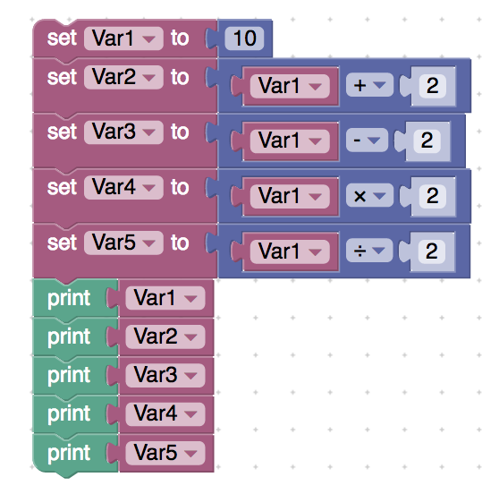

<xml xmlns="http://www.w3.org/1999/xhtml">

 <variables>

    <variable type="" id="*,lV:O9]V=@;iJO}p2/?">Var1</variable>

    <variable type="" id="1|(vdXAr5tg^;##J+BZ*">Var2</variable>

    <variable type="" id="`n2F%i@zey@j#D_$:Yx(">Var3</variable>

    <variable type="" id="idL9YP)lf^0({Ias/K?=">Var4</variable>

    <variable type="" id="zW}EI2x9L@ZyN#Y0/j}w">Var5</variable>

 </variables>

 <block type="variables_set" id="0=K:{+Y_rPspSV(f(z+l" x="-562" y="-238">

    <field name="VAR" id="*,lV:O9]V=@;iJO}p2/?" variabletype="">Var1</field>

    <value name="VALUE">

     <block type="math_number" id="8B!jrW)kAjx[NnqHrz!9">

       <field name="NUM">10</field>

     </block>

    </value>

    <next>

     <block type="variables_set" id="Ejypk`-Q3H7^dn)VzipT">

       <field name="VAR" id="1|(vdXAr5tg^;##J+BZ*" variabletype="">Var2</field>

       <value name="VALUE">

         <block type="math_arithmetic" id="N|,$my{FH;Tn:$VG-fXV">

           <field name="OP">ADD</field>

           <value name="A">

             <shadow type="math_number" id="I!j{,decl*~~bY+`d,`o">

               <field name="NUM">10</field>

             </shadow>

             <block type="variables_get" id="zEM:auoOz=*US8:KS*Bd">

               <field name="VAR" id="*,lV:O9]V=@;iJO}p2/?" variabletype="">Var1</field>

             </block>

           </value>

           <value name="B">

             <shadow type="math_number" id="%Y#u}k36n:3$ikTn)?TS">

               <field name="NUM">2</field>

             </shadow>

           </value>

         </block>

       </value>

       <next>

         <block type="variables_set" id="bH7Sy_BqH~q.DnFe8S-~">

           <field name="VAR" id="`n2F%i@zey@j#D_$:Yx(" variabletype="">Var3</field>

           <value name="VALUE">

             <block type="math_arithmetic" id="I{4-j-L1.TcVcx}k]PY|">

               <field name="OP">MINUS</field>

               <value name="A">

                 <shadow type="math_number" id="a~%u8?%Fo*aRyoM}6b9%">

                   <field name="NUM">10</field>

                 </shadow>

                 <block type="variables_get" id="Em8bSu[by]9m0#|g6O6/">

                   <field name="VAR" id="*,lV:O9]V=@;iJO}p2/?" variabletype="">Var1</field>

                 </block>

               </value>

               <value name="B">

                 <shadow type="math_number" id="(CVy{e6z;+_m7cRDJ0KU">

                   <field name="NUM">2</field>

                 </shadow>

               </value>

             </block>

           </value>

           <next>

             <block type="variables_set" id="LZ_e)Ey{af%hapBM8-1O">

               <field name="VAR" id="idL9YP)lf^0({Ias/K?=" variabletype="">Var4</field>

               <value name="VALUE">

                 <block type="math_arithmetic" id="9I|:)aZY64f(nTzL~JfF">

                   <field name="OP">MULTIPLY</field>

                   <value name="A">

                     <shadow type="math_number" id="%|%J:Mdp/#SCg)3*_-tz">

                       <field name="NUM">10</field>

                     </shadow>

                     <block type="variables_get" id="T}^a5m(Z@eceQ~8_9cB:">

                       <field name="VAR" id="*,lV:O9]V=@;iJO}p2/?" variabletype="">Var1</field>

                     </block>

                   </value>

                   <value name="B">

                     <shadow type="math_number" id="]_mx)1k@AGcVH59HrVQE">

                       <field name="NUM">2</field>

                     </shadow>

                   </value>

                 </block>

               </value>

               <next>

                 <block type="variables_set" id="p.3ESZBj#3Lk|,rv]Upk">

                   <field name="VAR" id="zW}EI2x9L@ZyN#Y0/j}w" variabletype="">Var5</field>

                   <value name="VALUE">

                     <block type="math_arithmetic" id="~BOF?K+b7,]QN_aM8I-6">

                       <field name="OP">DIVIDE</field>

                       <value name="A">

                         <shadow type="math_number" id="Wp3:-%9UCrK-F{}+z[m8">

                           <field name="NUM">10</field>

                         </shadow>

                         <block type="variables_get" id="3piZJHLztMyLwAxXKZBJ">

                           <field name="VAR" id="*,lV:O9]V=@;iJO}p2/?" variabletype="">Var1</field>

                         </block>

                       </value>

                       <value name="B">

                         <shadow type="math_number" id="Ll?gFwhtw.f2orRykFy!">

                           <field name="NUM">2</field>

                         </shadow>

                       </value>

                     </block>

                   </value>

                   <next>

                     <block type="text_print" id="Rp9!.J@Z*Qcr!RFXhd*^">

                       <value name="TEXT">

                         <shadow type="text" id="kGBiGZ=^!gjy.U_J+40o">

                           <field name="TEXT">abc</field>

                         </shadow>

                         <block type="variables_get" id="pn*Y,bzVy.ht!~U7A*ox">

                           <field name="VAR" id="*,lV:O9]V=@;iJO}p2/?" variabletype="">Var1</field>

                         </block>

                       </value>

                       <next>

                         <block type="text_print" id="H0$olSbzSgKUEcfcT($p">

                           <value name="TEXT">

                             <shadow type="text" id="0/?|fWVThpjbN=uATpYe">

                               <field name="TEXT">abc</field>

                             </shadow>

                             <block type="variables_get" id="jx*/p}}J*~b28==/4:Da">

                               <field name="VAR" id="1|(vdXAr5tg^;##J+BZ*" variabletype="">Var2</field>

                             </block>

                           </value>

                           <next>

                             <block type="text_print" id="jVT1]#aC@L5Rl,L=se%B">

                               <value name="TEXT">

                                 <shadow type="text" id="=EP.6Zgj!u$_:(ht#]Pb">

                                   <field name="TEXT">abc</field>

                                 </shadow>

                                 <block type="variables_get" id="}R#ML8]_H5Wjzz-nF6eP">

                                   <field name="VAR" id="`n2F%i@zey@j#D_$:Yx(" variabletype="">Var3</field>

                                 </block>

                               </value>

                               <next>

                                 <block type="text_print" id="Cv!_TxE[Pxm2F??INA8-">

                                   <value name="TEXT">

                                     <shadow type="text" id="vP)zJLxUDg;aWV6v8s17">

                                       <field name="TEXT">abc</field>

                                     </shadow>

                                     <block type="variables_get" id="gH.^#-;3mMr1IGNtf|sw">

                                       <field name="VAR" id="idL9YP)lf^0({Ias/K?=" variabletype="">Var4</field>

                                     </block>

                                   </value>

                                   <next>

                                     <block type="text_print" id="5_wo8mFfNcrP[h-v2Pd)">

                                       <value name="TEXT">

                                         <shadow type="text" id="*_!l=qje]g,ZXIFYw/hh">

                                           <field name="TEXT">abc</field>

                                         </shadow>

                                         <block type="variables_get" id="t=$4K`!_?PI8zj;ws7F`">

                                           <field name="VAR" id="zW}EI2x9L@ZyN#Y0/j}w" variabletype="">Var5</field>

                                         </block>

                                       </value>

                                     </block>

                                   </next>

                                 </block>

                               </next>

                             </block>

                           </next>

                         </block>

                       </next>

                     </block>

                   </next>

                 </block>

               </next>

             </block>

           </next>

         </block>

       </next>

     </block>

    </next>

 </block>

</xml>

* **Description:** Printing simple operations directly

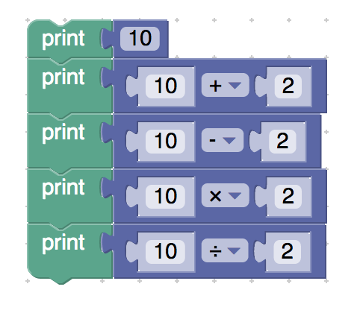

<xml xmlns="http://www.w3.org/1999/xhtml">

 <variables></variables>

 <block type="text_print" id="W{1+bUdi6F3W{95-Y4$T" x="-138" y="-138">

    <value name="TEXT">

     <shadow type="text" id="[AZ0`HtLAH(OJigt;HIV">

       <field name="TEXT">abc</field>

     </shadow>x

     <block type="math_number" id=".vRcjlh?!cGklL|7m[1%">

       <field name="NUM">10</field>

     </block>

    </value>

    <next>

     <block type="text_print" id="[JDX_A:P5*K)sb/C]dA9">

       <value name="TEXT">

         <shadow type="text" id="{%Ew,%=IUKNz2GQ(]QtX">

           <field name="TEXT">abc</field>

         </shadow>

         <block type="math_arithmetic" id="T/InN_%W;WrzV6_GjUf}">

           <field name="OP">ADD</field>

           <value name="A">

             <shadow type="math_number" id="S[[q1=O%O4Fm:#uK8-bj">

               <field name="NUM">10</field>

             </shadow>

           </value>

           <value name="B">

             <shadow type="math_number" id="}%h}zrY1[pILk}SF`^40">

               <field name="NUM">2</field>

             </shadow>

           </value>

         </block>

       </value>

       <next>

         <block type="text_print" id=":2.6k/+w}WudF_k$i3,{">

           <value name="TEXT">

             <shadow type="text" id="~m/x/Qs8/^Q%3zXO2YI5">

               <field name="TEXT">abc</field>

             </shadow>

             <block type="math_arithmetic" id="K$i;efS3kyYt9Y)h3m=C">

               <field name="OP">MINUS</field>

               <value name="A">

                 <shadow type="math_number" id="F!6?#y;=+K/GyF]9*kC-">

                   <field name="NUM">10</field>

                 </shadow>

               </value>

               <value name="B">

                 <shadow type="math_number" id="],Er@S~JZIEHNf_wr]xF">

                   <field name="NUM">2</field>

                 </shadow>

               </value>

             </block>

           </value>

           <next>

             <block type="text_print" id="A4Fxynn!BfH+(4^{3Hgn">

               <value name="TEXT">

                 <shadow type="text" id="~m/x/Qs8/^Q%3zXO2YI5">

                   <field name="TEXT">abc</field>

                 </shadow>

                 <block type="math_arithmetic" id="QzX{%ia#QebnDnT^e?5p">

                   <field name="OP">MULTIPLY</field>

                   <value name="A">

                     <shadow type="math_number" id="$.6jMlsoFs{rp$8Wla8x">

                       <field name="NUM">10</field>

                     </shadow>

                   </value>

                   <value name="B">

                     <shadow type="math_number" id="%wr+}{R.cs?.PC~7{Is8">

                       <field name="NUM">2</field>

                     </shadow>

                   </value>

                 </block>

               </value>

               <next>

                 <block type="text_print" id="5b/@dJeAh*_-M2O#QM=%">

                   <value name="TEXT">

                     <shadow type="text" id="~m/x/Qs8/^Q%3zXO2YI5">

                       <field name="TEXT">abc</field>

                     </shadow>

                     <block type="math_arithmetic" id="ea}m|@TuI~SG{%5xU;uH">

                       <field name="OP">DIVIDE</field>

                       <value name="A">

                         <shadow type="math_number" id="SO-O_7fmBZz69P+=Os^G">

                           <field name="NUM">10</field>

                         </shadow>

                       </value>

                       <value name="B">

                         <shadow type="math_number" id="},+14`dTlk_cj{FGk/Uu">

                           <field name="NUM">2</field>

                         </shadow>

                       </value>

                     </block>

                   </value>

                 </block>

               </next>

             </block>

           </next>

         </block>

       </next>

     </block>

    </next>

 </block>

</xml>

**Description:** assigning the values of the simple operations directly

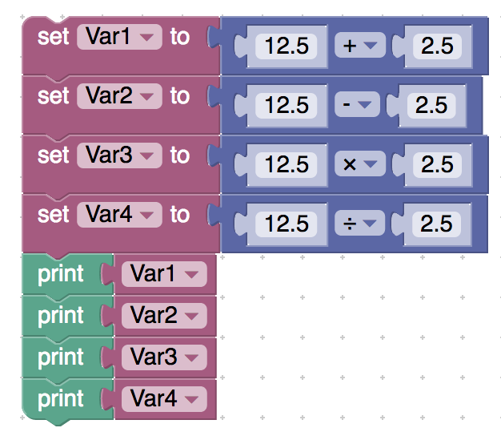

<xml xmlns="http://www.w3.org/1999/xhtml">

 <variables>

    <variable type="" id="E(ZF@jUM}`we(Q#,c)%y">Var1</variable>

    <variable type="" id="eXXjLdJ`du_6!hK%~6UL">Var2</variable>

    <variable type="" id="|nr.g4Bk^ZJ#GF|izP!%">Var3</variable>

    <variable type="" id="1^O?9Tr|d6v9{AaPmg=b">Var4</variable>

 </variables>

 <block type="variables_set" id="#[yN}1Ru~Ivm03(dHK`w" x="-188" y="-188">

    <field name="VAR" id="E(ZF@jUM}`we(Q#,c)%y" variabletype="">Var1</field>

    <value name="VALUE">

     <block type="math_arithmetic" id=".T^oEy:`nYPy:b|NEJOQ">

       <field name="OP">ADD</field>

       <value name="A">

         <shadow type="math_number" id="lTfm/~3P`h)IN|mf0.LJ">

           <field name="NUM">12.5</field>

         </shadow>

       </value>

       <value name="B">

         <shadow type="math_number" id="]q*6_/P9I]Y.hYoJvCn2">

           <field name="NUM">2.5</field>

         </shadow>

       </value>

     </block>

    </value>

    <next>

     <block type="variables_set" id=":ggXkPaS[]`NSMeC~7wI">

       <field name="VAR" id="eXXjLdJ`du_6!hK%~6UL" variabletype="">Var2</field>

       <value name="VALUE">

         <block type="math_arithmetic" id="NXIbSS:*iCUY89Hi6`Vj">

           <field name="OP">MINUS</field>

           <value name="A">

             <shadow type="math_number" id="F4|Rr)E]CccSS-3h/oo=">

               <field name="NUM">12.5</field>

             </shadow>

           </value>

           <value name="B">

             <shadow type="math_number" id="k=PBx9KSB~}fa7#,-wcS">

               <field name="NUM">2.5</field>

             </shadow>

           </value>

         </block>

       </value>

       <next>

         <block type="variables_set" id="wMRH6KF:I5MpNt$B(HB?">

           <field name="VAR" id="|nr.g4Bk^ZJ#GF|izP!%" variabletype="">Var3</field>

           <value name="VALUE">

             <block type="math_arithmetic" id="d}AK6:hOrCwsK3U!B5tU">

               <field name="OP">MULTIPLY</field>

               <value name="A">

                 <shadow type="math_number" id="~PcFk*Zak:Ua9r~A2PM(">

                   <field name="NUM">12.5</field>

                 </shadow>

               </value>

               <value name="B">

                 <shadow type="math_number" id="A!cX+]rcFK~bNv[_z?A?">

                   <field name="NUM">2.5</field>

                 </shadow>

               </value>

             </block>

           </value>

           <next>

             <block type="variables_set" id="(^cgF7)O`5N-LyiyB%Zw">

               <field name="VAR" id="1^O?9Tr|d6v9{AaPmg=b" variabletype="">Var4</field>

               <value name="VALUE">

                 <block type="math_arithmetic" id="|)AIZwSi1jE42eBpi}B2">

                   <field name="OP">DIVIDE</field>

                   <value name="A">

                     <shadow type="math_number" id="Jwgn=B[AXj|uq~:`o;K5">

                       <field name="NUM">12.5</field>

                     </shadow>

                   </value>

                   <value name="B">

                     <shadow type="math_number" id="m3U(~}|tNRyFP+$DFHdx">

                       <field name="NUM">2.5</field>

                     </shadow>

                   </value>

                 </block>

               </value>

               <next>

                 <block type="text_print" id="_7YPRZSA3y:H(F3|Plt[">

                   <value name="TEXT">

                     <shadow type="text" id="7%1W?(_aK7`,6Xug|-)2">

                       <field name="TEXT">abc</field>

                     </shadow>

                     <block type="variables_get" id="fMCm,z/(0iBPMCxpj^BS">

                       <field name="VAR" id="E(ZF@jUM}`we(Q#,c)%y" variabletype="">Var1</field>

                     </block>

                   </value>

                   <next>

                     <block type="text_print" id="tV_n^43r@[5lp-5cwowv">

                       <value name="TEXT">

                         <shadow type="text" id="7%1W?(_aK7`,6Xug|-)2">

                           <field name="TEXT">abc</field>

                         </shadow>

                         <block type="variables_get" id="*]L_7,gEF]rj#lF42=}/">

                           <field name="VAR" id="eXXjLdJ`du_6!hK%~6UL" variabletype="">Var2</field>

                         </block>

                       </value>

                       <next>

                         <block type="text_print" id="F9,4*X+-g!jciIgP6Znd">

                           <value name="TEXT">

                             <shadow type="text" id="7%1W?(_aK7`,6Xug|-)2">

                               <field name="TEXT">abc</field>

                             </shadow>

                             <block type="variables_get" id="XdxZ(+Dsf/P;Gsn*iGEL">

                               <field name="VAR" id="|nr.g4Bk^ZJ#GF|izP!%" variabletype="">Var3</field>

                             </block>

                           </value>

                           <next>

                             <block type="text_print" id="xDg--QJm5)dFs7|?^:xe">

                               <value name="TEXT">

                                 <shadow type="text" id="7%1W?(_aK7`,6Xug|-)2">

                                   <field name="TEXT">abc</field>

                                 </shadow>

                                 <block type="variables_get" id="aVP(|m|PF^g$3S.]}u@[">

                                   <field name="VAR" id="1^O?9Tr|d6v9{AaPmg=b" variabletype="">Var4</field>

                                 </block>

                               </value>

                             </block>

                           </next>

                         </block>

                       </next>

                     </block>

                   </next>

                 </block>

               </next>

             </block>

           </next>

         </block>

       </next>

     </block>

    </next>

 </block>

</xml>

* **Math power of 2 integers**

**Description:** Assigning the value of the power of 2 integers to a variable

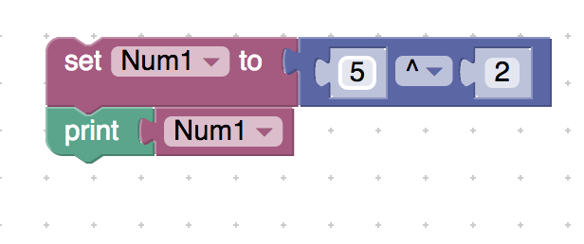

<xml xmlns="http://www.w3.org/1999/xhtml">

 <variables>

    <variable type="" id="I*t*:h#H:-l5ut!aNh*5">Num1</variable>

 </variables>

 <block type="variables_set" id="{WsBKUm74KQwaFZ-!%@q" x="137" y="38">

    <field name="VAR" id="I*t*:h#H:-l5ut!aNh*5" variabletype="">Num1</field>

    <value name="VALUE">

     <block type="math_arithmetic" id="b_OSpv:s4V^Kt]ZyA(E[">

       <field name="OP">POWER</field>

       <value name="A">

         <shadow type="math_number" id="***RNxt2jgZwr/juN,X,">

           <field name="NUM">5</field>

         </shadow>

       </value>

       <value name="B">

         <shadow type="math_number" id="wbj2_/g9}diLlLxI_Hi5">

           <field name="NUM">2</field>

         </shadow>

       </value>

     </block>

    </value>

    <next>

     <block type="text_print" id="oQa-F-f*W3XtM@aO%6Tr">

       <value name="TEXT">

         <shadow type="text" id="^/l@()2KF(.BHKS.`yXZ">

           <field name="TEXT">abc</field>

         </shadow>

         <block type="variables_get" id="-2OBv5yI:^Dt;Fd.F/!,">

           <field name="VAR" id="I*t*:h#H:-l5ut!aNh*5" variabletype="">Num1</field>

         </block>

       </value>

     </block>

    </next>

 </block>

</xml>

* **Modular Division (Mod Operator)**

**Description:** Printing the remainder of 2 numbers directly

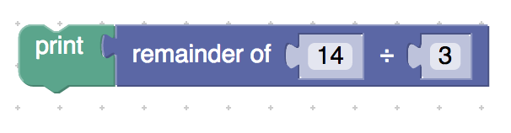

<xml xmlns="http://www.w3.org/1999/xhtml">

 <variables></variables>

 <block type="text_print" id="nzJMCMO$(z]/,O~Bt`5C" x="88" y="38">

    <value name="TEXT">

     <shadow type="text" id="E~y9.xL@v6R~.fstT4ty">

       <field name="TEXT">abc</field>

     </shadow>

     <block type="math_modulo" id="|SA*ZYQ0)]Us~^07AZvF">

       <value name="DIVIDEND">

         <shadow type="math_number" id="@$`LB[}SD-=-Zdr@}ZNr">

           <field name="NUM">14</field>

         </shadow>

       </value>

       <value name="DIVISOR">

         <shadow type="math_number" id="xIKD*ZBOln%7vSr6I1Gt">

           <field name="NUM">3</field>

         </shadow>

       </value>

     </block>

    </value>

 </block>

</xml>

* **Variable Update Operators**

**Description:** Concatenating 2 strings using the + operator

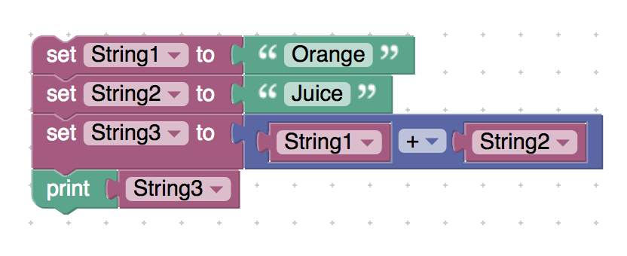

<xml xmlns="http://www.w3.org/1999/xhtml">

 <variables>

    <variable type="" id="e?fZ_Xk;^|`4Af`jMvtI">String1</variable>

    <variable type="" id="LGF:zrob+]+X:ycHa@%W">String2</variable>

    <variable type="" id=".rf/w{;{2TYlu{o~[5t=">String3</variable>

 </variables>

 <block type="variables_set" id="#4@_a,uK#?`6E+88QE3P" x="63" y="113">

    <field name="VAR" id="e?fZ_Xk;^|`4Af`jMvtI" variabletype="">String1</field>

    <value name="VALUE">

     <block type="text" id="oF.-HZGWS6MJ4luNC)tA">

       <field name="TEXT">Orange</field>

     </block>

    </value>

    <next>

     <block type="variables_set" id="c)z8!tk6h]%;PqpdErVp">

       <field name="VAR" id="LGF:zrob+]+X:ycHa@%W" variabletype="">String2</field>

       <value name="VALUE">

         <block type="text" id="D]zhafEZrpaAy?Fk}_+S">

           <field name="TEXT">Juice</field>

         </block>

       </value>

       <next>

         <block type="variables_set" id="RF#--3=PUr`qL?|S#fg7">

           <field name="VAR" id=".rf/w{;{2TYlu{o~[5t=" variabletype="">String3</field>

           <value name="VALUE">

             <block type="math_arithmetic" id=":oD[2DPA`/s775G!)2`M">

               <field name="OP">ADD</field>

               <value name="A">

                 <shadow type="math_number" id="fZIH[;xHPJzEK/JzfUPG">

                   <field name="NUM">1</field>

                 </shadow>

                 <block type="variables_get" id="8O~rXx%3_YnP/ko}b2P{">

                   <field name="VAR" id="e?fZ_Xk;^|`4Af`jMvtI" variabletype="">String1</field>

                 </block>

               </value>

               <value name="B">

                 <shadow type="math_number" id="i{xj9UZhu~6hvv)vqa*A">

                   <field name="NUM">1</field>

                 </shadow>

                 <block type="variables_get" id="MFA,9msP*W/mIsUnKPXt">

                   <field name="VAR" id="LGF:zrob+]+X:ycHa@%W" variabletype="">String2</field>

                 </block>

               </value>

             </block>

           </value>

           <next>

             <block type="text_print" id="6aT9yVNn{1TlEGzlamYC">

               <value name="TEXT">

                 <shadow type="text" id="{FAXlN[LY*,rxDeId9.+">

                   <field name="TEXT">abc</field>

                 </shadow>

                 <block type="variables_get" id="G8T3bzR3NKH%dit.DV([">

                   <field name="VAR" id=".rf/w{;{2TYlu{o~[5t=" variabletype="">String3</field>

                 </block>

               </value>

             </block>

           </next>

         </block>

       </next>

     </block>

    </next>

 </block>

</xml>

**Description:** Printing the result of the + operator on 2 strings directly

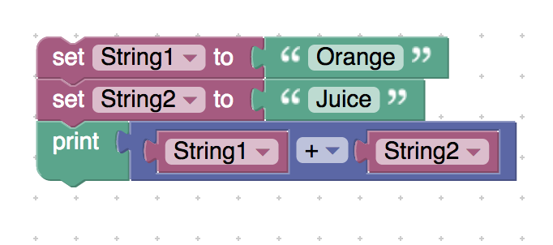

<xml xmlns="http://www.w3.org/1999/xhtml">

 <variables>

    <variable type="" id="e?fZ_Xk;^|`4Af`jMvtI">String1</variable>

    <variable type="" id="LGF:zrob+]+X:ycHa@%W">String2</variable>

 </variables>

 <block type="variables_set" id="#4@_a,uK#?`6E+88QE3P" x="138" y="138">

    <field name="VAR" id="e?fZ_Xk;^|`4Af`jMvtI" variabletype="">String1</field>

    <value name="VALUE">

     <block type="text" id="oF.-HZGWS6MJ4luNC)tA">

       <field name="TEXT">Orange</field>

     </block>

    </value>

    <next>

     <block type="variables_set" id="c)z8!tk6h]%;PqpdErVp">

       <field name="VAR" id="LGF:zrob+]+X:ycHa@%W" variabletype="">String2</field>

       <value name="VALUE">

         <block type="text" id="D]zhafEZrpaAy?Fk}_+S">

           <field name="TEXT">Juice</field>

         </block>

       </value>

       <next>

         <block type="text_print" id="6aT9yVNn{1TlEGzlamYC">

           <value name="TEXT">

             <shadow type="text" id="{FAXlN[LY*,rxDeId9.+">

               <field name="TEXT">abc</field>

             </shadow>

             <block type="math_arithmetic" id="{hJj*]5_V2Wrt=5`N*E7">

               <field name="OP">ADD</field>

               <value name="A">

                 <shadow type="math_number" id="7}A4o8,r6BpgTnqbKwh2">

                   <field name="NUM">1</field>

                 </shadow>

                 <block type="variables_get" id="y9BX:-%J#0[I+AGJEpq)">

                   <field name="VAR" id="e?fZ_Xk;^|`4Af`jMvtI" variabletype="">String1</field>

                 </block>

               </value>

               <value name="B">

                 <shadow type="math_number" id="GaF*t-ywcXXU+x=1P8}.">

                   <field name="NUM">1</field>

                 </shadow>

                 <block type="variables_get" id="6o8Iy74=8t,V`dm$TE-:">

                   <field name="VAR" id="LGF:zrob+]+X:ycHa@%W" variabletype="">String2</field>

                 </block>

               </value>

             </block>

           </value>

         </block>

       </next>

     </block>

    </next>

 </block>

</xml>

* **Description: Input number**

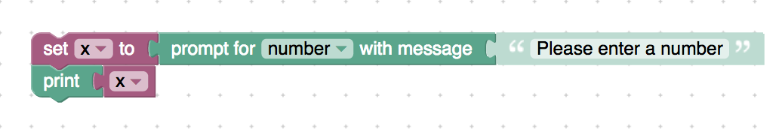

<xml xmlns="http://www.w3.org/1999/xhtml">

 <variables>

    <variable type="" id="ovXoCe|(%y*~m}oNuvrt">x</variable>

 </variables>

 <block type="variables_set" id="pm=sEa~4noW]A$k0;~G/" x="137" y="112">

    <field name="VAR" id="ovXoCe|(%y*~m}oNuvrt" variabletype="">x</field>

    <value name="VALUE">

     <block type="text_prompt_ext" id="C8#sSMn=V!34BDG#.+,]">

       <mutation type="NUMBER"></mutation>

       <field name="TYPE">NUMBER</field>

       <value name="TEXT">

         <shadow type="text" id="{*jU{r%KNz?a=^z%OcQR">

           <field name="TEXT">Please enter a number</field>

         </shadow>

       </value>

     </block>

    </value>

    <next>

     <block type="text_print" id=")]lmiXeUTr(CZ;oH]9wp">

       <value name="TEXT">

         <shadow type="text" id="NiTGry!Xx[uN7j2(slYq">

           <field name="TEXT">abc</field>

         </shadow>

         <block type="variables_get" id="Vu]d;%wl]mA^%9kAys@9">

           <field name="VAR" id="ovXoCe|(%y*~m}oNuvrt" variabletype="">x</field>

         </block>

       </value>

     </block>

    </next>

 </block>

</xml>

* **Description:** Inputing a number and printing the result of that number + 5

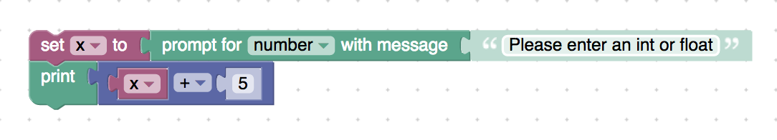

<xml xmlns="http://www.w3.org/1999/xhtml">

 <variables>

    <variable type="" id="ovXoCe|(%y*~m}oNuvrt">x</variable>

 </variables>

 <block type="variables_set" id="pm=sEa~4noW]A$k0;~G/" x="137" y="112">

    <field name="VAR" id="ovXoCe|(%y*~m}oNuvrt" variabletype="">x</field>

    <value name="VALUE">

     <block type="text_prompt_ext" id="C8#sSMn=V!34BDG#.+,]">

       <mutation type="NUMBER"></mutation>

       <field name="TYPE">NUMBER</field>

       <value name="TEXT">

         <shadow type="text" id="{*jU{r%KNz?a=^z%OcQR">

           <field name="TEXT">Please enter an int or float</field>

         </shadow>

       </value>

     </block>

    </value>

    <next>

     <block type="text_print" id=")]lmiXeUTr(CZ;oH]9wp">

       <value name="TEXT">

         <shadow type="text" id="NiTGry!Xx[uN7j2(slYq">

           <field name="TEXT">abc</field>

         </shadow>

         <block type="math_arithmetic" id="#HyZ#zNt$[tdV:7HE6ae">

           <field name="OP">ADD</field>

           <value name="A">

             <shadow type="math_number" id="L1@xekNY8W!ze/[~e%;r">

               <field name="NUM">1</field>

             </shadow>

             <block type="variables_get" id="Vu]d;%wl]mA^%9kAys@9">

               <field name="VAR" id="ovXoCe|(%y*~m}oNuvrt" variabletype="">x</field>

             </block>

           </value>

           <value name="B">

             <shadow type="math_number" id="J_JEpD+fmP-,3rP?+Sv^">

               <field name="NUM">5</field>

             </shadow>

           </value>

         </block>

       </value>

     </block>

    </next>

 </block>

</xml>